Multiple choice section

|  |  |  |  |  |  |  |  |  |
| --- | --- | --- | --- | --- | --- | --- | --- | --- |
| Question | 1 | 2 | 3 | 4 | 5 | 6 | 7 | 8 |
| Answer | C | B | C | D | B | C | B | C |

Question 1 [7.1]

C

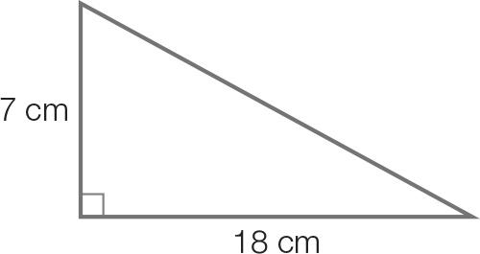

Use Pythagoras’ theorem to find the length of the diagonal.

x2 = 72 + 182

x2 = 49 + 324

x2 = 373

x = 

x = 19.313...

x = 19 cm (correct to the nearest cm)

Question 2 [7.1]

B

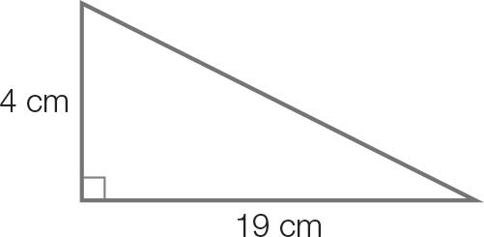

Use Pythagoras’ theorem to find the length of the diagonal.

(Use the unrounded value 19.313... in calculations)

x2 = 19.3132 + 42

x2 = 373 + 16

x2 = 389

x = 

x = 19.723…

x = 20 cm (correct to the nearest whole number)

Question 3 [7.2]

C

tan (347) = tan (360 − 347) = −tan (13)

Question 4 [7.2]

D

Period = 360 Amplitude = 1.5

Question 5 [7.3]

B



In the 1st quadrant, x = tan-1 (1) = 45. In the 4th quadrant, x = 360 − 45 = 315.

Question 6 [7.4, 7.5]

A

 = 

x = 

Question 7 [7.6]

B

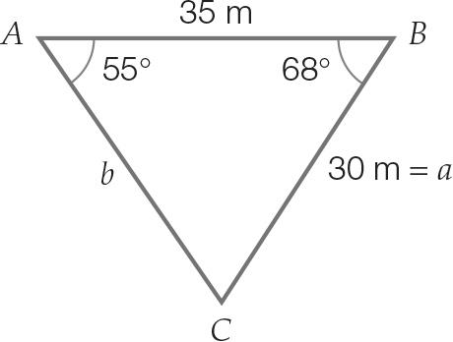

A b2 = 302 + 352 – 2 × 30 × 35 × cos (68): this equation can be used to find side length b.

B Area = ½ × 30 × 35 × 55: this is incorrect. Area = ½ × 30 × 35 × sin(68.

C : this equation could also be used to find side length b.

D *****ACB* = 180° − (55° + 68°): this equation can be used to calculate the unknown angle *C*.

Question 8 [7.6]

C

A = ab sin (θ)  
=  × 7 × 9 × sin (48) = 23 cm2 (correct to the nearest square centimetre)

Multiple-choice total marks: 8

Short answer section

Question 9 4 marks [7.1]

(a) AC2 = 102 + 142  
AC2 = 100 + 196  
AC2 = 296  
AC =   
AC = 17.204…  
AC = 17 cm

(b) Use half of the diagonal for the base of the triangle (8.6 cm). The height is 18 cm.   
tan (θ) =   
θ = tan-1   
θ = 64.46  
Therefore the required angle is 64 (to the nearest degree).

Question 10 2 marks [7.1]

Let r be the radius.





Question 11 2 marks [7.1]

Length of diagonal BC = = 20 cm

tan (angle with base) = 

angle with base = tan-1

= 50.194…

= 50

Question 12 2 marks [7.2]

(a) sin (141) = sin (180 − 141)  
= sin (39)

(b) tan (314) = tan (360 − 314)  
= −tan (46)

Question 13 2 marks [7.3]

cos (x) = 

In the 1st quadrant, cos (x) is positive.

In the 2nd quadrant, cos (x) is negative.

In the 3rd quadrant, cos (x) is negative.

In the 4th quadrant, cos (x) is positive.

Therefore, the solutions will be found in both the 1st and 4th quadrants, where the solutions are positive.

Question 14 2 marks [7.2]

sin (φ) is negative in the 3rd and 4th quadrants.

−sin (45) = sin (180 + 45) or sin (360 – 45)

= sin (225) or sin (315)

φ = 225 or 315

Question 15 2 marks [7.3]



First quadrant solution:



cos (θ) is positive in the 1st and 4th quadrants.

In the 4th quadrant, x = 360 – 45 = 315

Therefore the solutions between 0 ≤ θ ≤ 360 are 45 and 315.

Question 16 4 marks [7.4]

**(a)** c2 = a2 + b2 – 2ab cos (θ)  
842 = 772 + 922 – 2 × 77× 92 × cos (θ)  
7056 = 14 393 – 14 168 × cos (θ)  
−7337 = –14 168 × cos (θ)  
cos (θ) =    
θ = cos-1   
θ = 58.811…  
θ = 59 (to the nearest degree)

(b) The sine rule can be used to calculate the second angle.  
   
B = 69.242…  
B = 69 (correct to the nearest degree)  
To find the third angle, subtract the two known angles from 180.  
C = 180 − (59 + 69)  
C = 52

Question 17 6 marks [7.5]

(a) α = 50  
θ = (180 − 50)  
 = 130

(b) Use cosine formula.  
Let x be the length AC  
x2 = 402 + 202 – 2 × 40 × 20 × cos (130)  
  
x = 55.031 km

(c) Distance saved = 40 + 20 – 55.031  
= 4.9685… km  
= 4968.55 m  
= 4969 m (to the nearest metre)

Question 18 2 marks [7.6]

Area =  × 41 × 45 × sin (163)

= 269.71 cm2 (2 d.p.)

Short answer total marks: 28

Extended response section

Question 19 8 marks [7.4, 7.5, 7.6]

(a)

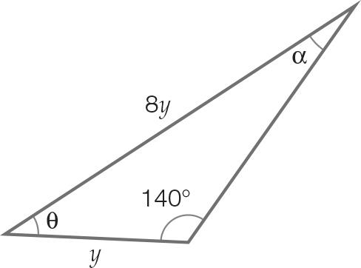

(b)   
  
Therefore the included angle θ = 180 – (140 + 5) = 35

(c) Area =  × y × 8y × sin (35)

(d) Area =  × y × 8y × sin (35)  
69 500 = 4 sin (35) × y2   
 y2 = 30292.38…  
 y = 174.05  
 y = 174.05 m  
Therefore, it is 174 m (correct to the nearest metre).

Question 20 10 marks [7.6]

(a) Using Pythagoras’ theorem:   
Length BD =   
 = 94.201… m   
 = 94 m

(b) Let θ = ∠BDC   
tan (θ) =   
θ = 37.23  
θ = 37  
c = 53

(c) ∠ABD = 120 – ∠CBD  
 = 120 −53  
 = 67   
 ∠ADB = 125 – ∠CDB  
 = 125 – 37  
 = 88  
  
 AD = 82.895  
 = 83 m (correct to the nearest m)

(d) Area of ΔBCD =  × 57 × 75   
 = 2137.5 m2  
Area of ΔABD =  × 90 ×  × sin (67.23)  
 = 3908.859… m2  
Total area = 2137.5 + 3908.859.…  
 = 6046 m2 (correct to the nearest m)

(e) Perimeter = 83 + 90 + 57 + 75  
 = 305 m  
Fencing length required = 305 m

Question 21 4 marks [7.2, 7.3]

(a) Period = 12 hours  
Amplitude = 1.5 m

(b) 12 noon Sunday

Extended answer total marks: 22

TOTAL test marks: 58